

**MEMORANDUM OF UNDERSTANDING**

This is a document validating an agreement between **MR. OGABOR JOHN AND MRS. OTUTU GEORGINA** for the collaborative of 20% interest over a sum of **FIVE HUNDRED THOUSAND NAIRA ONLY (₦500,000) paid on the 21st of May, 2020.**

There is a binding agreement to pay the initial capital invested, alongside the interest, **SIX HUNDRED THOUSAND NAIRA ONLY (₦600,000) on the 21st of June, 2020** by **MR. OGABOR JOHN TO MRS. OTUTU GEORGINA.**

Attached with this document is an evidence of payment by **MRS. OTUTU GEORGINA.**

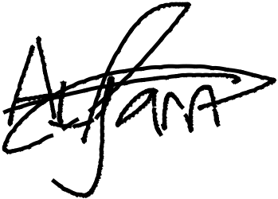

_________________________

_~~__~~_____~~___~~_~~_~~___________



**MRS. OTUTU GEORGINA**

**MR. OGABOR JOHN**

***(CEO, JOHN INVESTMENTS)***